**Street parties**

These blocks, or street bands represent the city's diverse communities and their love for music and dance. They have unique rhythms and styles. Their parties are much more casual than the [parades](https://www.carnivalbookers.com/rio-de-janeiro/samba-parade/samba-parade) in the Sambadrome.

Blocos is a big part of the carnival, attracting locals and tourists with samba, costumes, and energy for many years. Every Block provides a special experience for singles, families, or gays, allowing them to fully enjoy the real Brazilian carnival atmosphere.

But what truly sets these blocks apart is their inclusivity. Everyone, regardless of age, gender, or background, is invited to join in the festivities.

In Rio, different cultures mix on the streets. Samba and modern music blend well, while traditional and modern dances combine. The blocks are where friendships are forged, stories are shared, and memories are made.

As the sun rises and the city lights up, the blocks come alive, turning Rio's streets into a dance floor. Drums fill the air, sequins shimmer, and revelers laugh. As the day progresses, the boundaries between performer and spectator blur, with everyone becoming a part of the carnival magic.

So, if you find yourself in Rio during Carnival, don't just be a spectator. Join a bloco.

Dance to samba beats. Let the city's carnival spirit sweep you away in the heart of the festivities. After all, in Rio, Carnival is not just an event; it's a way of life.

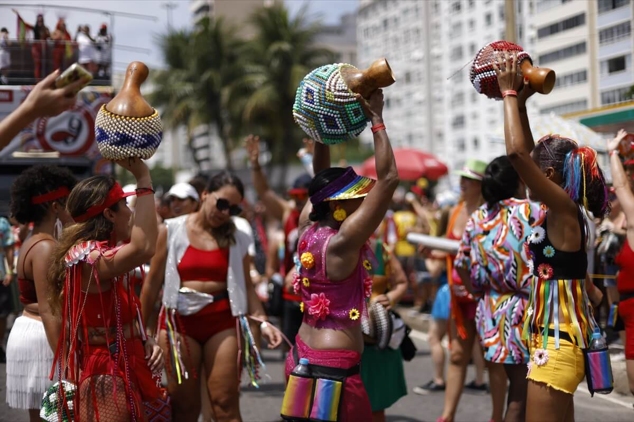

**History of the Bloco**

In Rio de Janeiro, samba drums and dancers create a lively atmosphere, leading to the famous Rio Carnival street party. The famous celebration began in the late 1800s. Spirited groups called Cordões gathered during this time. Their purpose was to bring happiness and music to the streets of the city.

The Cordões were special groups. They played music and created dances for the community. These groups are now the basis of today's carnival celebrations on the streets.

The evolution of the Rio Carnival street party is a testament to the city's rich cultural tapestry. Over time, these Cordões transformed into "blocos," free street parties that stream through Rio's streets and plazas during Carnival.

Today, millions of excited people fill the streets of Rio de Janeiro, all wanting to join this amazing party. Rio's Carnival street party is not just a festival. It is a vibrant display of the city's strength, energy, and everlasting passion for music and dance.

**Modern Blocos**

Today the Blocos form their parades in specific neighborhoods. Each Bloco consists of a musical band and a group of partiers.

The Blocos organize and run block parties during the year. The parades start as early as January and then run through the Sunday after the Carnival. While the Blocos parade in just about every neighborhood, the most popular neighborhoods for these parties are [Copacabana](https://www.carnivalbookers.com/rio-de-janeiro/rio-neighborhood-guide/copacabana), [Leblon](https://www.carnivalbookers.com/rio-de-janeiro/rio-neighborhood-guide/leblon), Ipanema, [Jardim Botanico](https://www.carnivalbookers.com/rio-de-janeiro/rio-neighborhood-guide/jardim-botanico), and Lagoa as well as downtown.

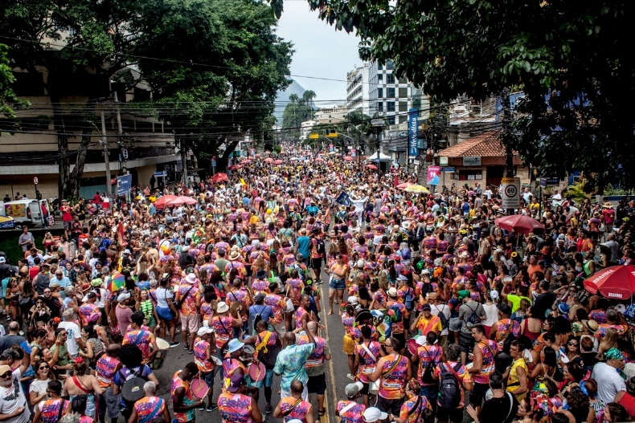

Many of these Blocos write their own theme songs and add classic samba songs to their repertoire. The Cordão do Bola Preta, and Suvaco do Cristo are very popular Blocos. One of the oldest Blocos, Monobloco, is so popular that they play concerts year-round.